2013 Year 9 Chemical Sciences - End of Unit Test

Name: ___________________ Class: __________ Mark: _____ /50

SECTION A --Multiple Choice : Write the letter of the answer that you think is most correct

- In a plant’s photosynthesis reaction carbon dioxide (CO₂) reacts with water (H₂O) to form glucose (C₆H₁₂O₆) and oxygen gas (O₂) the equation below
. CO₂ + H₂O C₆H₁₂O₆+ O₂
The products of this reaction are:
A oxygen and glucose
B carbon dioxide and water
C carbon dioxide and oxygen gas
D carbon dioxide, water, glucose and oxygen gas
Answer: ____

- Emily and Alice added Hydrochloric acid to Magnesium ribbon. Which of the following gasses were produced?
A Hydrogen.
B Helium.
C Oxygen.
D Carbon dioxide.
Answer: ____

- Ihaka and Jordan have a drink made from lemons and sugar. They add two drops of universal indicator to the drink. What colour change would they see?
A Red to green.
B Green to red.
C Blue to red.
D Green to blue.
Answer: ____

- The drink that was mentioned in Question 3, had sugar added. Without the sugar the drink would have been too:
A Sour.
B Bitter.
C Basic.
D Sweet.
Answer: ____
- Molly, Sara and Michelle mixed Hydrochloric acid with sodium hydroxide. They heated the mixture in an evaporating dish until all that was left was a white powder.

The white powder would have been:
A Sodium metal
B Base.
C Chlorine.
D Salt
Answer: ____

- Which one of the following formula would represent a base?
A Ca (OH)₂
B Na Cl
C Fe Cl₃
D H Cl
Answer: ____

- Which of the following will turn red litmus paper blue?
A Vinegar.
B Sodium hydroxide.
C Distilled water.
D Glucose solution.
Answer: ____

8. An acid reacts with a metal. Identify its products.
A a salt + hydrogen gas
B a salt + water
C a salt + water + carbon dioxide
D glucose + oxygen gas
Answer: ____

9. The element Aluminum has an electron configuration of (2, 8, 3) How many valence electrons does Aluminum have in its outer shell?

A 8
B 13
C 2
D 3
Answer: ____

10. The reaction that releases energy for your cells to use is called:
A photosynthesis
B respiration
C corrosion
D neutralisation

Answer: ____

11. Acids are corrosive. pH measures the amount of what particles in a solution?
A H+ ions
B acid particles
C OH– ions
D base particles
Answer: ____

12. The atomic symbol for a gold atom is 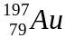. What does this tells you about the gold atom.
A It contains 118 protons.
B It contains a total of 197 protons, neutrons and electrons.
C It contains 118 neutrons.
D It contains 197 electrons.
Answer: ____

13. Which of the statements best describes a particle with
17 protons, 16 neutrons and 18 electrons.
A It is an ion because it has lost an electron.
B It is an atom because it has gained an electron.
C It is an atom that has lost a proton.
D It is an ion because it has gained an electron.
Answer: ____

14. A zinc (Zn) atom has an atomic number of 30 and an atomic mass of 65,
which statement best describes the number of subatomic particles in its ion Zn²⁺.

A 35 protons, 30 neutrons, 32 electrons
B 30 protons, 35 neutrons, 28 electrons
C 30 protons, 65 neutrons, 28 electrons
D 30 protons, 35 neutrons, 32 electrons
Answer: ____

END OF SECTION A - MULTIPLE CHOICE

SECTION B ___ Written section. Answer all of the questions in the spaces provided.

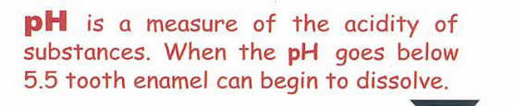
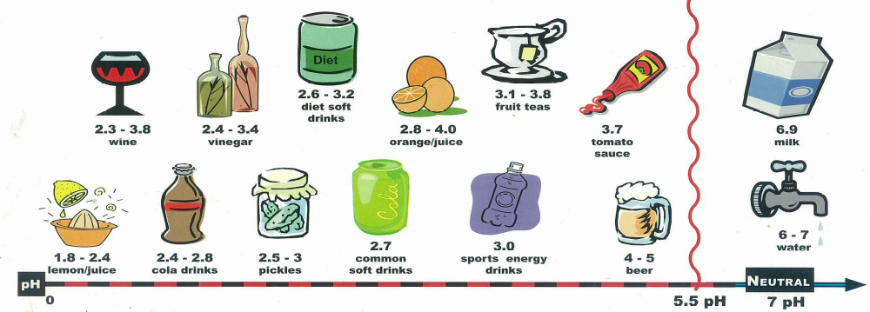
- Read the chart and answer the questions below

1a. Which two drinks would a dentist recommend to reduce tooth enamel decay?
__________________________________
__________________________________ (1 mark)

1b. Casey and Suaad were selecting foods for their party from the chart list these items from least acidic to most acidic

cola drink
tomato sauce
lemon juice
fruit tea
milk
sport energy drink

LEAST ACIDIC MOST ACIDIC

________________________________________________________________________
(1 mark)

- Complete the table

Name | Formula
Hydrochloric acid
 | HNO₃
Sulphuric acid
 | Ca (OH)₂
Magnesium hydroxide
Acetic acid (vinegar)
(3 marks)
- Steven and Sharif did an experiment to see if acid was able to react with certain substances
Three substance samples were tested with strong acid and their reactions were recorded.
Substance | Reaction | Pop Test | Limewater test | pH
Substance X | Bubbles formed | Negative | Positive  Turned white colour | 4
Substance Y | Bubbles formed & heat | Positive | Negative | 3
Substance Z | Bubbles formed | Negative | Negative | 7

3a.
i. Which of the substances is likely to be a metal ? __________________________________

(1 mark)
ii. Explain why?_____________________________________________________________
__________________________________________________________________________________________________________________ (1 mark)

3b. What type of substance is substance X?_______________________________________
_______________________________________________________________ (1 mark)

4.Balance each of the following chemical equations
4a. ____CuSO₄ + ____Na OH → ____Cu(OH)₂ + ____Na₂SO₄ (1mark)

4b. ____ KOH + ____ H₂SO₄→ ____K₂SO₄ + ____H₂O (1mark)

4c. ____HCl + ___Fe → ____Fe Cl₃ + ____H₂ (1 mark)

4d. Write and balance as a chemical equation the acid/base reaction between
hydrochloric acid and sodium hydroxide (3 marks)

_______________________________________________________________________
4e. Write and balance as a chemical equation the reaction between
sulfuric acid and magnesium:

_______________________________________________________________________

(3 marks)

5a. Draw lines to match each term with the correct description:
TERM DESCRIPTION
lustrous able to be bent
malleable shiny
ductile shatters easily
brittle able to be stretched (2 marks)

5b. Complete the table to compare the characteristics of metals and non-metals.
Indicate if the substances have this feature
Characteristic | Metal | Non-Metal
Solid at room temperature
Malleable
Conducts electricity
Brittle

Shiny

Ductile

- marks)

6. Julian, Jacob and Tyrone placed a stick of chalk (calcium carbonate) into hydrochloric acid. It fizzed as the reaction produced carbon dioxide gas, water and calcium chloride

Write the word equation and a balanced chemical (symbol) equation
6a. Word Equation
Reactants -------------> Products

______________________________________________________________________
(2 marks)

6b. Chemical equation

______________________________________________________________________
(3 marks)

Julian, Jacob and Tyrone measured the amount of carbon dioxide gas generated as the (chalk) calcium carbonate reacted with acid. They repeated the experiment and this time they crushed the calcium carbonate into a powder before reacting. The results are shown in the table below.
Time (seconds) | Volume of CO₂ generated (cm³)
Time (seconds) | Stick of chalk Calcium Carbonate | Crushed /powder chalk Calcium Carbonate
0 | 0 | 0
15 | 50 | 100
30 | 100 | 200
45 | 150 | 200
60 | 200 | 200
105 | 200 | 200

6c. Identify the independent variable in this experiment?
____________________________________________ (1 mark)
6d. Identify the dependent variable in the experiment?
____________________________________________ (1 mark)

6e. Graph the data in a line graph --- include a legend for each type of chalk/ Calcium Carbonate

(5 marks)

6f. Select the best conclusion from the results:

A Chalk and Hydrochloric Acid react together
B Crushed chalk reacts faster than a stick of chalk
C Hydrochloric Acid burns

D Chalk always produces 200 cm³ of carbon dioxide

(1 mark)

END of TEST – Check through ALL your answers.

